npm install @auth0/angular-jwt

npm install @ng-bootstrap/ng-bootstrap

"styles": [

...

"node_modules/bootstrap/dist/css/bootstrap.min.css"

],

"scripts":[

...

"node_modules/bootstrap/dist/js/bootstrap.min.js"

]

ng add @angular/material

change tsconfig.json

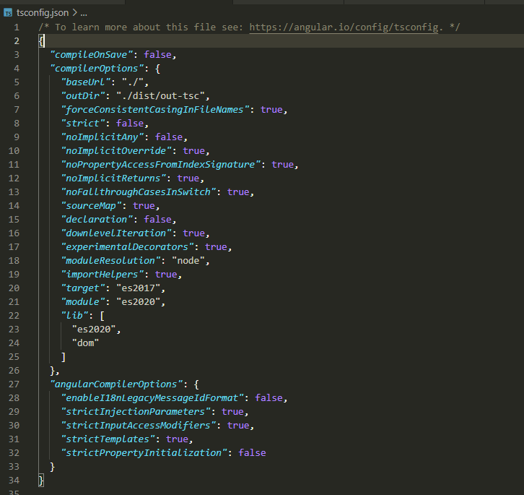

npm install moment